Al-Shafei School
Worksheet for Grade:______ Name: ___________
Colour the picture.
لون الصورة.
STOP: red
WAIT: yellow
GO: green

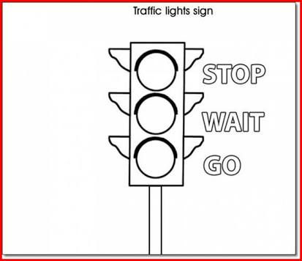
Enjoy your work

