Alshafei School
Road safety – worksheet
Name: ___________
Class: ___________

- Complete with the words in the box. اكمل الجمل من مخزن الكلمات

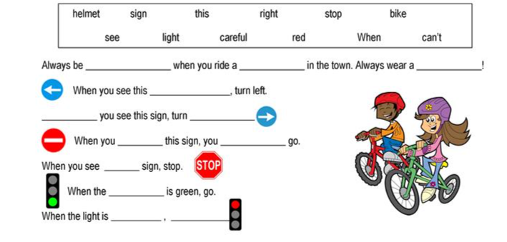

- Match the signs to their meanings. لائم الإشارة لمعناها
